MANOR LODGE FUNCTION ROOM
AT STOTFOLD CONSERVATIVE CLUB
PRIVATE PARTY RESERVATION FORM
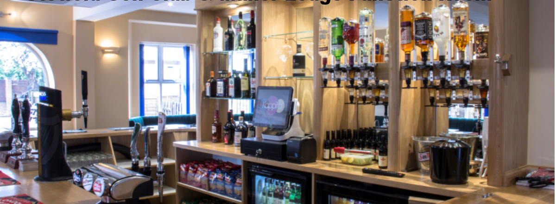
DATE NO. OF GUESTS START
OF EVENT (Max: 120) TIME
APPLICANT MEMBER
NAME NUMBER
ADDRESS

TEL EMAIL

TYPE OF FUNCTION

DJ BAND OTHER

TYPE OF FUNCTION | MEMBER (DEPOSIT) | PLEASE TICK | NON-MEMBER  (NON-REFUNDABLE) | PLEASE TICK
EVENING PARTY | £75 |  | £100
CHRISTENING | £75 |  | £100
WAKE | FOC |  | FOC
CHARITY EVENT | £75 |  | £100 (DEPOSIT)
21ST PARTY | £150 |  | £150
WEDDING | POA |  | POA
All prices correct at 01.04.2020
FEE’S RECEVIED:
FEES: | AMOUNT | PAYMENT TYPE | DATE RECEIVED
HALL HIRE
CLEANING DEPOSIT
DRINKS PACKAGE
BUFFET

OFFICE USE ONLY:
T’s & C’s Cleaning Form Drinks Package Buffet DJ Contract

