MANOR LODGE FUNCTION ROOM
AT STOTFOLD CONSERVATIVE CLUB
MEETINGS & CONFERENCE RESERVATION FORM
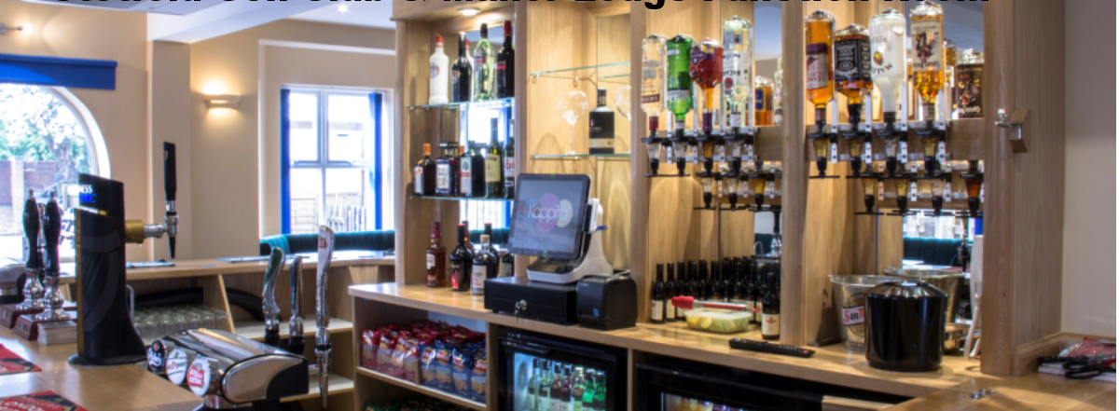
DATE NO. OF DELEGATES START
OF EVENT DELEGATES (Max: 120) TIME
COMPANY
NAME
COMPANY
ADDRESS
TEL CONTACT NAME
END TIME
(approx.)

TYPE OF FUNCTION | PRICE | PLEASE TICK | PAYMENT TYPE | DATE RECEIVED
CONFERENCE HALL (5-30)
CONFERENCE HALL (31-60)
CONFERENCE HALL (61-90)
CONFERENCE HALL (91-120)
TEA/COFFEE ON ARRIVAL
BISCUITS MID MORNING
TEA/COFFEE REPLENISHED
COLD BUFFET
HOT BUFFET
TEA/COFFEE REPLENISHED
USE OF BAR
EVENING HOT MEAL | From the menu
All prices correct at 01.04.2020

PROJECTOR
AV EQUIPMENT
SCREEN
FLIP CHART How Many ……………………………….
PAPER/PENS
PARKING How Many ……………………………….
HOTEL INFO
EVENING BAR
EVENING MEAL How Many ……………………………….

